**CS5228 Tutorial 5 – Graphs**

**Q1: Centrality Measures on a Directed Graph**

The centrality of a node in a graph is a way of measuring its importance among all other nodes w.r.t. the graph structure. Figure 1 shows a directed graph G.

For a directed graph, we can compute closeness of a node v as the maximum length of paths from other nodes **to the node v**, and the betweenness is defined similarly to the undirected case.

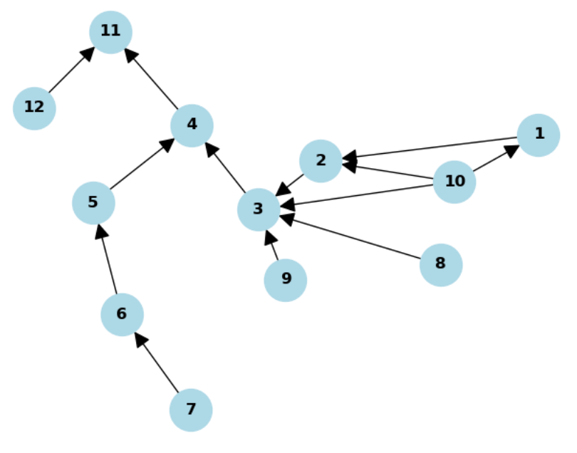

Simply by eye-balling graph G try to identify the nodes with the highest score according to the 4 centrality measures:

* Out-degree
* In-degree
* Closeness
* Betweenness

**Q2: Centrality Measures on MRT Map**

We have a dataset of MRT stations, which are nodes:

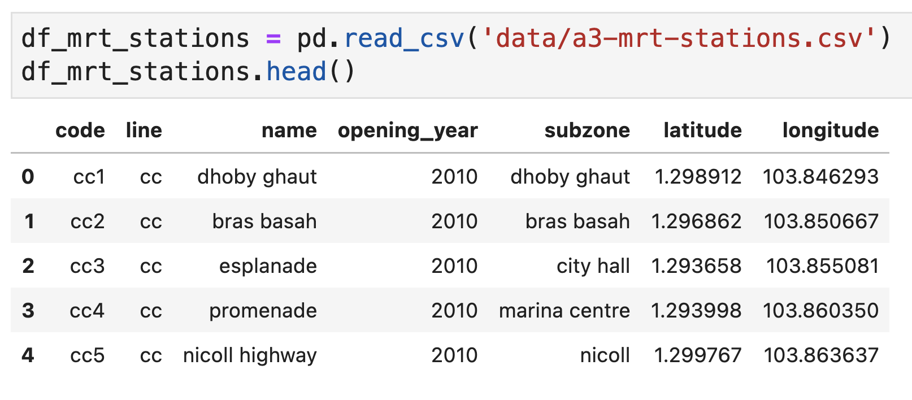

We also have the connections between them, which are edges:

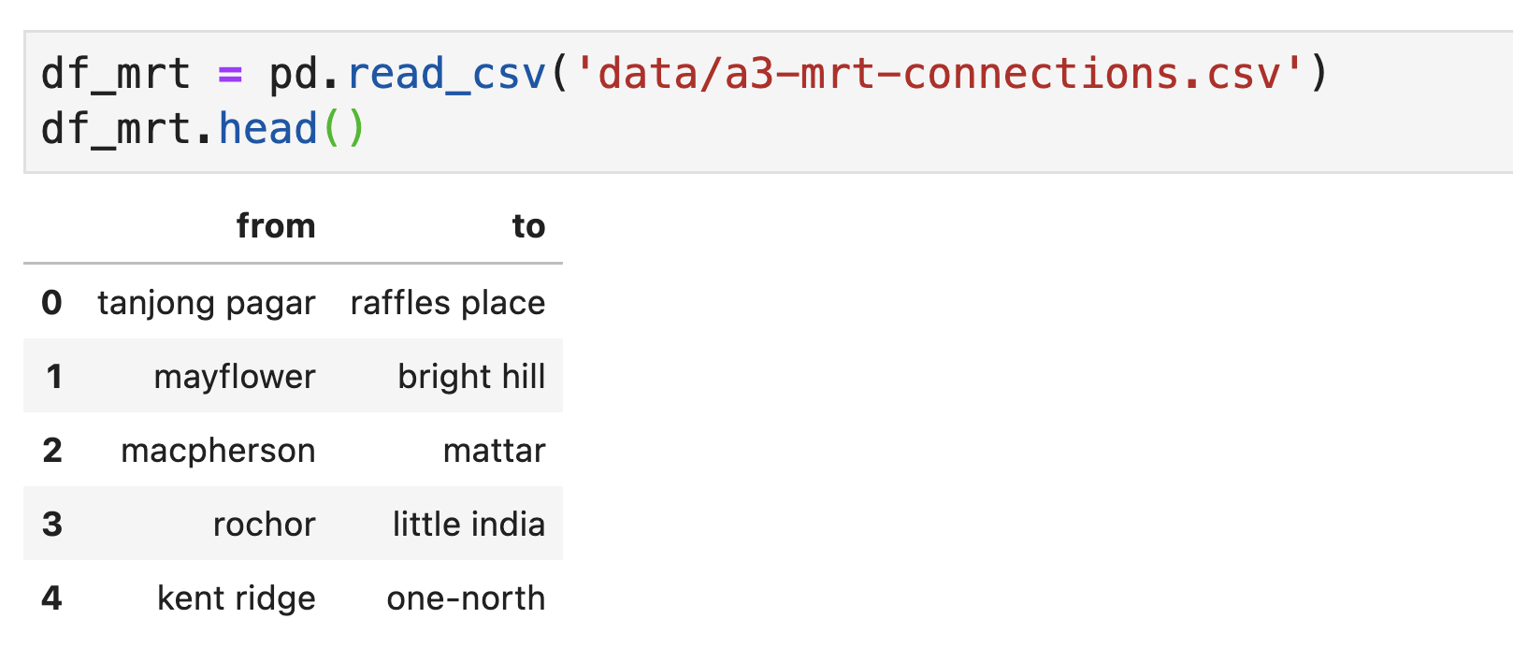

Converting this to a networkx graph:

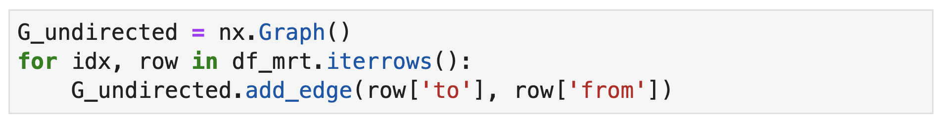

Finally, we can visualize the graph (using the “spring_layout” layout in networkx), producing the following result:

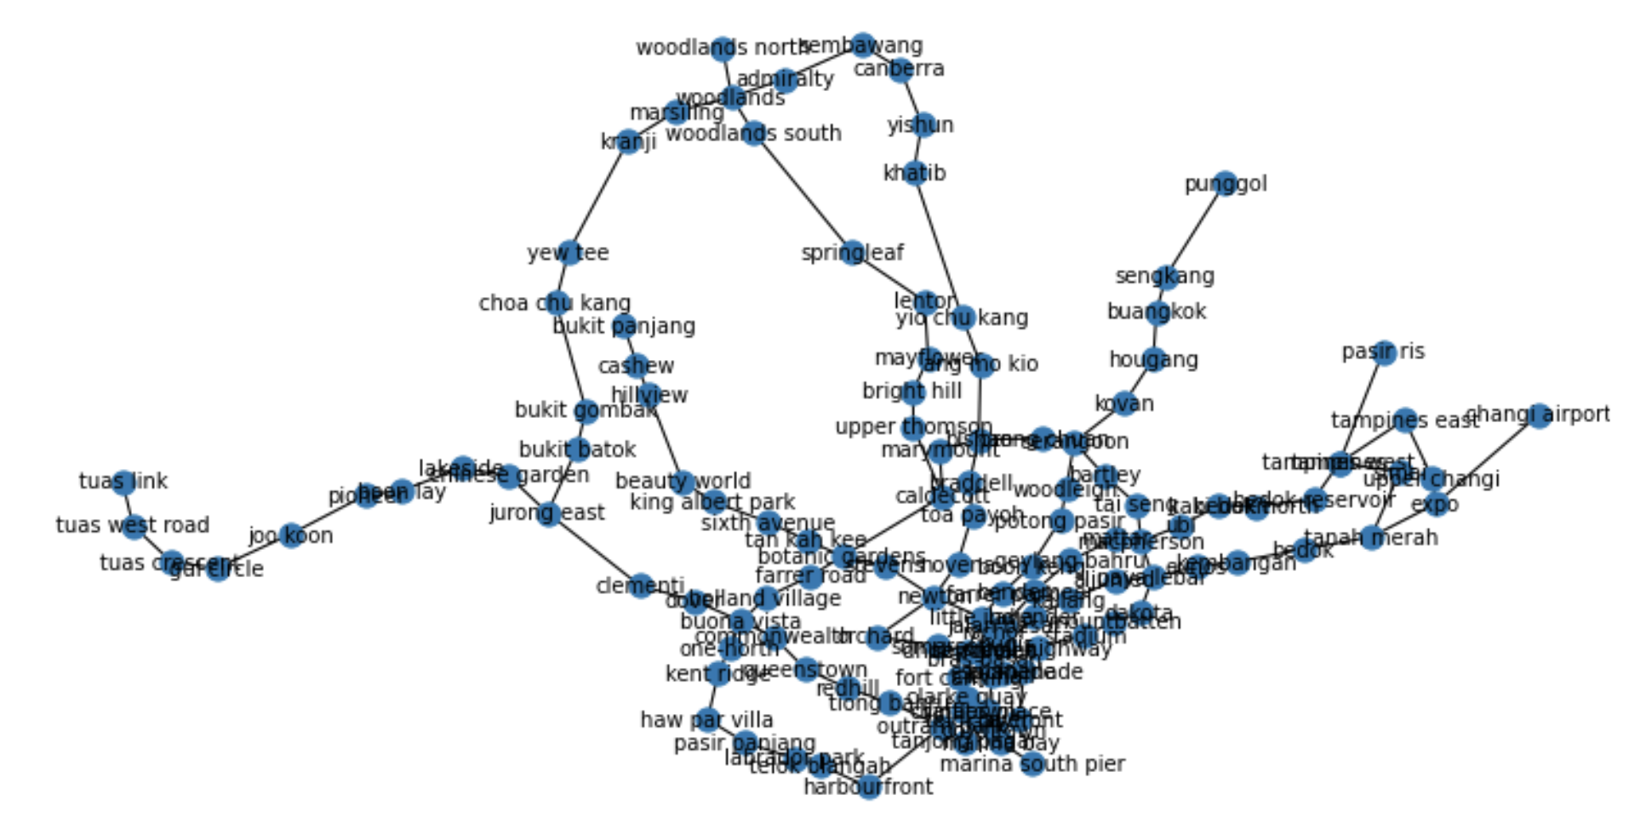

**2a)** We have 3 centrality measures: degree, centrality, betweenness. For one measure, the top 5 highest centrality stations are as follows. Which measure is it?

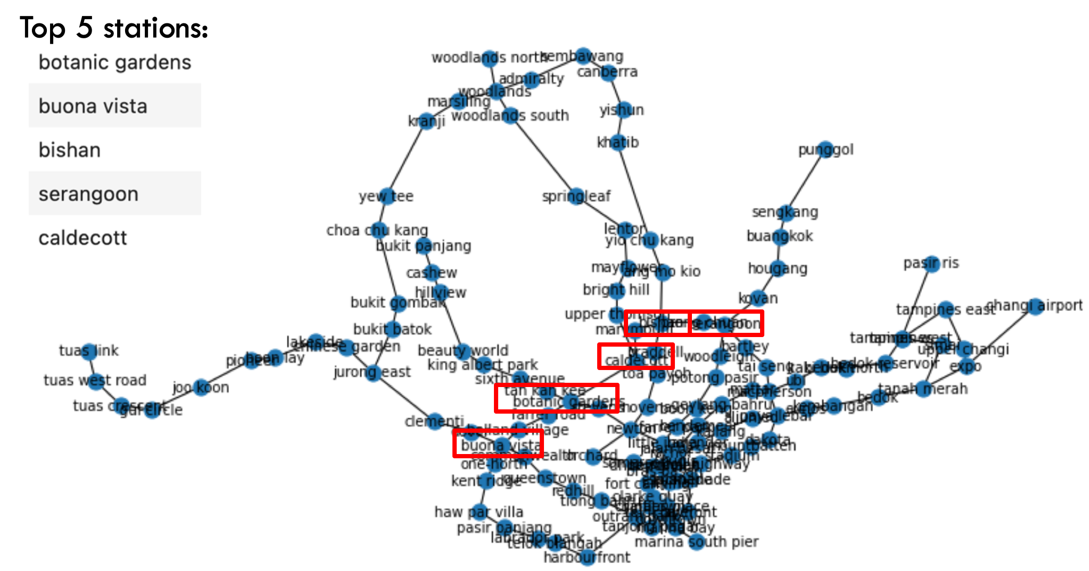

**2b)** For the next centrality measure, the top 5 highest centrality stations are as follows. Which centrality measure is it?

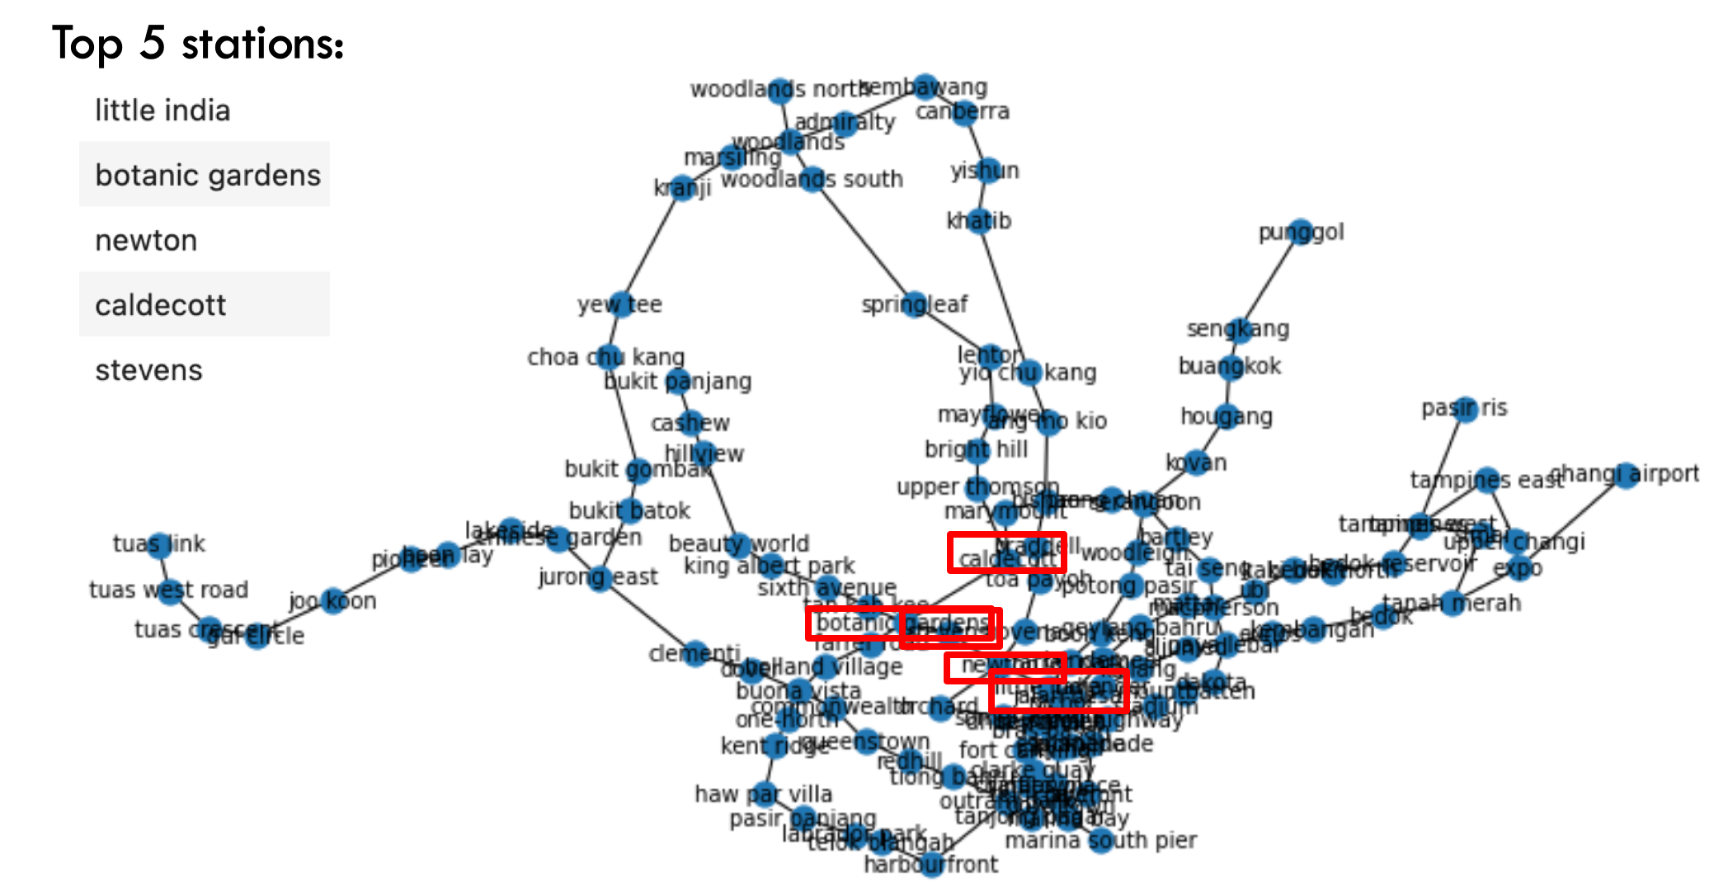

**2c)** Finally, the last centrality measure (which can be determined by elimination) is:

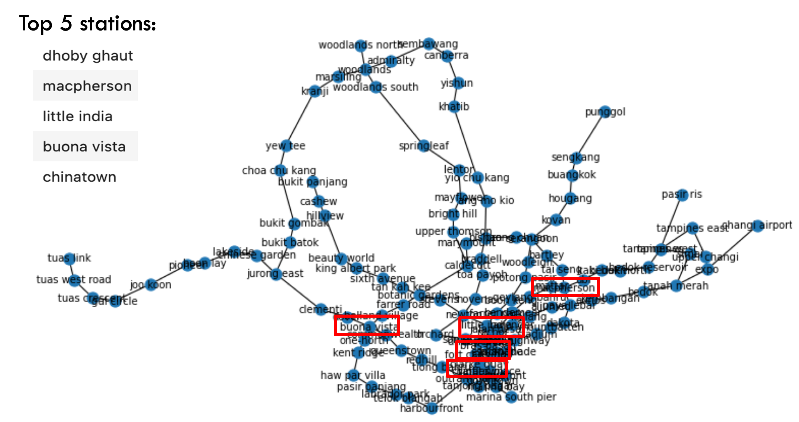

**2d)** For each of closeness and betweenness, come up with 1 concrete application scenario utilizing that centrality measure on the MRT graph, and discuss why that centrality measure is suitable.

**2e)** Most likely, the suitability of the centrality measures in the previous question’s scenarios are likely to be over-simplifications. For each of your scenarios, discuss one practical limitation of using that centrality measure in the scenarios you have come up with.

**2f)** We can run the Girvan-Newman algorithm to obtain “communities” of the nodes in this MRT map. The Girvan-Newman Algorithm iteratively removes a minimum set of edges until the graph breaks into 2 components. Edge with the highest Edge Betweenness Centrality are removed first. The resulting communities are as follows:

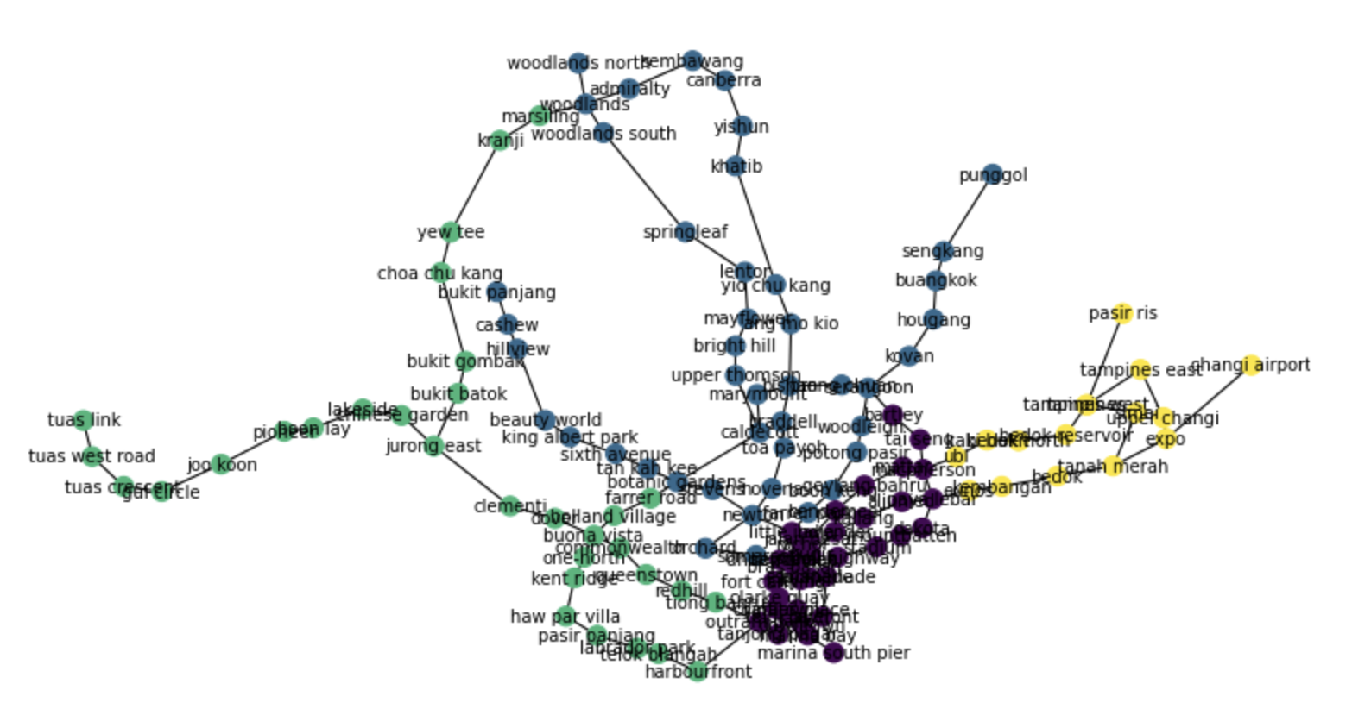

Do you think these communities make sense? We can see some rather sparse and large clusters (e.g. green) and some tightly connected and smaller clusters (e.g. black). Why do you think this is the case?